So You Teach a Gateway Course…
To help increase retention and keep students better informed of their academic standing, Gateway Courses should utilize both the Grade Center and Analytics for Learn tools within their Drexel Learn course shells. This document will give an overview of how to set this up for your students and utilize them throughout the term.
If you are already using the Grade Center in your course, then all you need to do is make sure that you have a calculated total of some kind that will show the students their overall progress in the course. This column should also be set as the External Grade, which is referenced on page 4.

How Do I Use This Document?
Below are the steps to set up your course. If you have already used it, follow only the steps you need.
- Setting up the Grade Center:
  - Create all of the columns for all of your graded items throughout the term
    - If you don’t know how many of a particular item you will assign, you can use Categories to allow for more dynamic calculations.
  - Create a calculated column that will total the students’ grades across the term
    - This will include defining a Grading Schema that sets what percentage values are assigned an A+, A, A-, B+, etc.
    - Setting this calculated column as the External Grade
    - An alternative is provided for folks who will manage their grades external to Learn, but still need to report them through this interface
- Enable and provide student access to the Analytics for Learn report

Setting up the Grade Center

How to Access the Full Grade Center
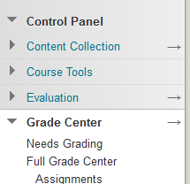
In order to set up the Grade Center in Learn, the first thing you need to do is navigate to it. To access the Grade Center from within your course, do the following:
- In the Control Panel area, click on the Grade Center link
- Click on the Full Grade Center link
- This will display all of your students and all grade columns
Once you are in the Grade Center, you will need to create columns. There are two main ways in which columns are created: manually or by creating a gradable item within the course. Details are provided for both of these processes.
TIP: Clicking on the arrow to the right of Grade Center will take you directly to the Full Grade Center, saving you a click.
Faculty who are managing grades external to Learn, possibly utilizing a spreadsheet, should first create all of their columns using the steps provided below. This will ensure that the right type of column is created before uploading grades.

Manually Creating a Column
When you need to enter a grade for something like an in class test or participation, you should manually create a column in the Grade Center. To create a new column, do the following:
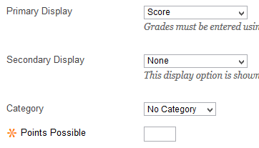
- Access the Full Grade Center
- Click on the Create Column button
- Fill out the appropriate fields:
  - Column Name is the title of the column
  - Grade Center Name is only seen by the Instructor
  - Primary Display is how the students will see the column
  - Secondary Display is only seen by the Instrutor
  - Points Possible must have a value, even if that is zero
- Click Submit to create the column
A full list of fields and descriptions can be found on the Grade Columns page.

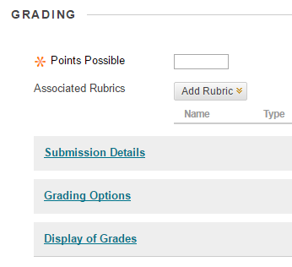
Automatic Columns
If you create gradable Assignments, Discussions, Tests, etc., they will automatically have a column created and linked in the Grade Center. To the right, you can see the Grading options for when an Assignment is created.
Grading for these items is typically done by accessing the student submissions, either through the Needs Grading view on the left menu, or through the Full Grade Center. Once graded, the grade will automatically flow over to the Grade Center.

Create a Calculated Column
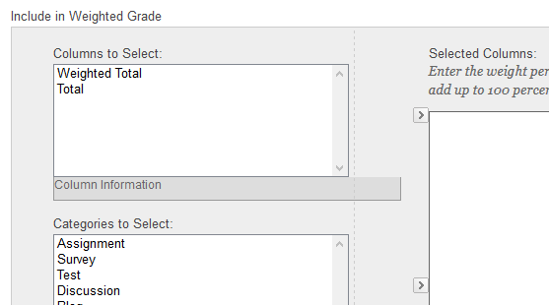
Once you have all of your columns created, you can create the calculated column. Utilizing a Weighted Total Column you can create a calculation that weights all of the grade columns appropriately and automatically calculates a grade. To set up this column, do the following:
- Click on the Options icon to the right of the Weighted Total column
- Select Edit Column Information
- Under Columns to Select, move Columns and/or Categories over to the Selected Columns box
  - The Total Weight for all columns and categories should equal 100%
- Click Submit to commit the changes
More information about weighted columns can be found on the Calculate Grades page. You can also find out more information about the Running Total option options from the ITG Blog.

Running Total
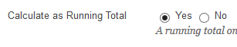
When calculating grades, the Calculate as Running Total option should be set to Yes. This will ensure that only columns that contain grades will be included in calculations. That being the case, if a student does not submit an assignment or misses a test, be sure to enter a zero for that column. This can always be updated after the fact, but if the column is left blank then that column is not being included in calculations and is not reporting the grade properly.

What about Variable Number of Assignments/Tests/Other?
If you are not sure how many of a particular assignment, discussion, test, quiz, etc. that you are going to assign to your students, but you know that all of them will be a certain portion of their overall grade, then you can utilize Categories. In setting up the calculation above, Categories allow you to say that every column associated with a particular Category will be counted in the calculation.
For example, if you are going to give in class quizzes every day, but you are not sure if you will skip a day here or there, then you may have 10 quizzes at the end of the term, but you may only have 7, or 5. If you assign every quiz to a Weekly Quiz Category, and then add that Weekly Quiz Category to the calculation, then the number of quizzes you complete in a term does not matter. Everything that is associated with the Category will be counted.

Creating a Category
Faculty can create as many categories as necessary within their course. To create a new Category, do the following:
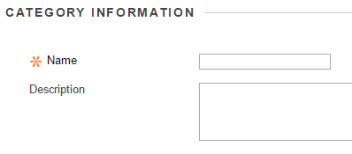
- Navigate to the Full Grade Center
- Hover over the Manage button
- Click on Categories
- Click on the Create Category button at the top left
- Enter a Name and Description for the Category
- Click Submit
Once the category is created, it is available to assign to any column within the Grade Center.

Associating Columns with a Category
After creating all of the necessary Categories, there are two ways that they can be associated with a course: when creating or editing a column or in bulk through Manage Columns.

Adding/Modifying the Category When Creating or Editing a Column
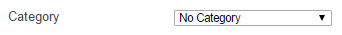
If you create a new column or edit an existing column, you will see a dropdown menu to select the Category. To assign a Category in this way, select the appropriate Category from the menu and click Submit.

Bulk Categorization Through Manage Columns
If you already have a number of columns created, rather than going through and reassigning the Category one at a time, you can update them in bulk through the Mange Columns. To make these changes, do the following:
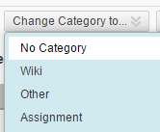
- Navigate to the Full Grade Center
- Hover over the Manage button
- Click on Column Organization
- Check the box to the left of every column you want to update
- Hover over Change Category to… at either the top or bottom of the screen
- Select the Category you want to assign
- Click Submit
Now all of those columns will be associated with the selected Category.
TIP: Using Manage Columns is a good way to see information that is not readily visible in the Full Grade Center, like Category, Due Date and Points Possible.

External Grade
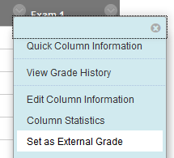
There is one column in the Grade Center that is flagged as the External Grade. This is the column that will be reported through Analytics for Learn as the student’s grade. It is important that the External Grade is set to the appropriate column in the Grade Center. To set the External Grade column to your calculated column, you can do the following:
- Access the Full Grade Center
- Click on the Options icon to the right of the Weighted Total column
- Select Set as External Grade
You will see the green checkmark appear to the left of the Weighted Total column.

Grading Schema
A Grading Schema provides a translation within Drexel Learn from a numeric percentage grade to a letter grade. It also allows for the direct entry of a letter grade, and then assigns a specific numeric value to any grade entered that way. To create a Grading Schema that works for your grades, you can do the following:
- Access the Full Grade Center
- Hover over the Manage button
- Click on Grading Schemas
- Click the options icon to the right of Letter
- Choose copy
- Click on the options icon to the right of the new schema, it should be Letter(2)
- Choose Edit
- Change the name of the schema to represent where they are from, like ENGL-101 Letter
- Make the necessary additions, deletions, and changes to the schema
- Click Submit
You will now see this schema as a choice in the Primary Display and Secondary Display dropdowns for all columns in the Grade Center. Reassign the appropriate display for your columns as necessary.
TIP: If you would round up a 96.5% to a 97% to give a student an A+ instead of an A, update your schema based on how you round grades. You can make this change to your schema at any time.

What if All My Columns Add Up to 100 Points?
If all of the columns in your Grade Center add up to 100 points, then all of your columns are already appropriately weighted for your course. That being the case, the Total column, which sums up all of the available columns in the Grade Center, can be used to report students’ grades. Make sure to flag this column as the External Grade.

What is the Payoff for All This Work? The Grade Submit Tool
When you utilize the Grade Center in the manner described above, you will be able to push your students’ Final Grades directly from Drexel Learn in to Banner using the Grade Submit Tool. You get to choose when this is done, and which grades are pushed. Information about this tool can be found on the Registrar’s website.

Analytics for Learn
There are four reports that are provided to faculty under Evaluation > Course Analytics: Course At-a-Glance, Activity and Grade Scatter Plot, Activity Matrix, and Course Submission Summary. From the Course At-a-Glance report, faculty can click on a link to any of their students to drill down to a detail report for that student. That detailed report is what you can make available to your students, so that they can see how their performance compares with everyone else in the class.

Adding the Analytics Student Report
To make the student analytics report available to your course, do the following:
- In the Control Panel, click on Customization
- Click on the Tool Availability link
- Scroll down to the Course Analytics (Student Report) entry
- Check the first box to the right of that title
- Click Submit
- Hover over the plus sign at the top left of the Course Menu
- Choose Tool Link from the list
- Enter a Name for the link
- Choose Course Analytics (Student Report) from the Type dropdown
- Check the Available to Users box
- Click Submit
This will add a new link, with the name you provided, to your course menu. When a student clicks on the link, they will see their Course At-a-Glance entry, which shows them how their activity in the course compares to the average student in the same course.
More information is available on the Instructional Technology Blog for the Course At-a-Glance report, the Student At-a-Glance report, as well as others.

Technical Support
If you have any questions, please contact the Instructional Technology Group at 215.895.1224 or itg@drexel.edu. You can also stop by their office in Korman Center Room 109 weekdays from 8:00am to 5:00pm where you can work with someone one-on-one.

Additional Information and Support
You can find more information about Grading on the Blackboard Help Site.

